S: Hartman, Ethan H

Monroe Community college

Smart Fan

Training user manual

Project Setup:

Materials:

* 1x Freenove Motor
* 1x Freenove Servo
* 2x F to M jumper cable
* 14x M to M jumper cable
* 2x Push button
* 1x Speaker
* 1x Potentiometer
* 1x LED
* 2x 1k Resistor
* 2x 10k Resistor

Wiring Diagram:

Computer Set up:

If the user would like to edit the code, the main.c file contains the control for the project. There are descriptive methods and variables which the user can process if they’d please. To load the program to the dragonboard, CodeWarrior must be set up previously and the user should copy the main.c code over. Next, the user should select the HCS12 Serial Monitor and Run and Debug the program, ensuring the LOAD switch is down on the dragonboard. Now, the program should be loaded on the dragonboard. The user may now exit out of the CodeWarrior debug pane. If the user wises to see the output text when toggling the device state, they should download MGTech MiniIDE. Once downloaded, the program should be opened, display the terminal, and press the Terminal connect / Disconnect button. When this is done, when the user toggles the state of the fan, it will be output to the MiniIDE Terminal.

Device Instruction:

1. Begin steps once computer set up has been completed
2. Ensure all internal switches labeled PH7- PH0 are up, besides bit 1 and 7. Bit 1 must be down at all times. 7 can be up or down.
3. To toggle the fan state, Internal Switch 5 can be pressed. If the fan is off, this will turn it on. If the fan is on, this will turn it off.
4. The user may dial the potentiometer to change the speed of the fan and display the current speed on the LCD.
5. To swivel the fan, switch 1 bit 7 must be up. To keep the fan stationary, it must be down.
6. To set a timer, the user must press the top external button once
   1. Once pressed, the lcd will display the text: “Insert a Time:”
   2. The user may then insert the time for how long they’d like the fan to be on for in the format hh:mm:ss. This prefix gets filled from right to left. (ex. User input: 539 – 5 minutes and 39 seconds.
   3. Pressing the ‘D’ Key will delete the last pressed number.
   4. Pressing the top external button again will set the timer, and the countdown will be displayed on the LCD.
   5. (optional) If no text is entered, the timer will be cleared
7. To set a temperature trigger, the user must press the bottom external button once
   1. Once pressed, the lcd will display the text: “Temperature (F):”
   2. The user may then insert the temperature in F for the temperature they’d like the fan to auto-turn on at if the fan is off.
   3. Pressing the ‘D’ Key will delete the last pressed number.
   4. Pressing the bottom external button again will set the temperature point
   5. (optional) If no temperature is entered, the temperature set will be cleared

Project Flow: 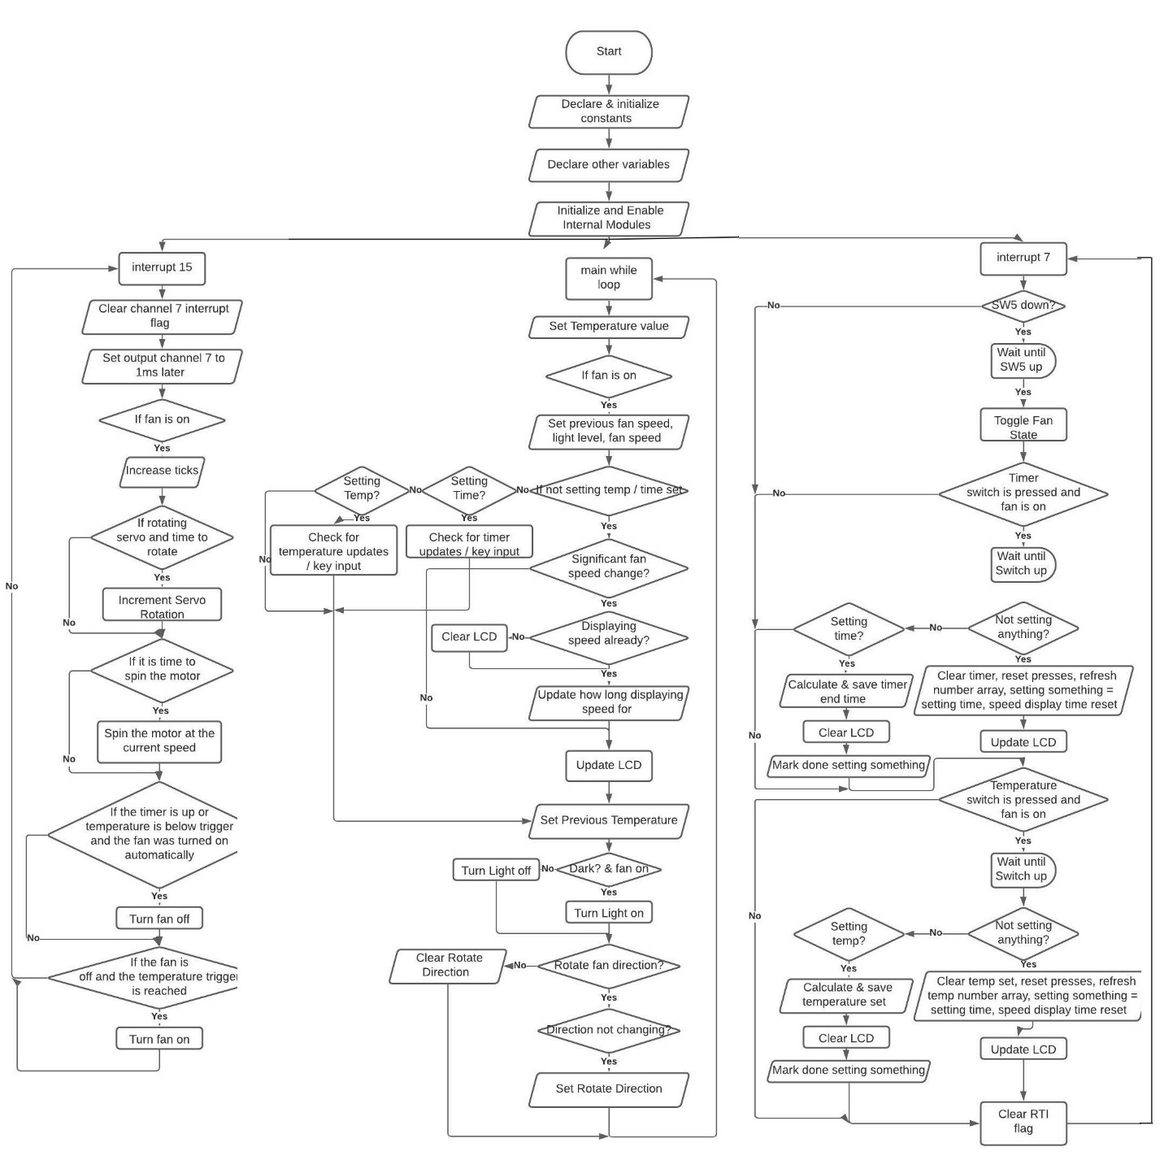

Output Detail:

LEDS & 7 Segment Display:

* All internal LED’s and 7-segment display lights can be ignored. The user does not need to know why they are on.
* The single external blue LED will turn on if the fan is on and it is dark in the room. It will be off if the fan is off, or it is light in the room.

LCD:

* If the LCD says, “Timer is Off”, that means no timer is set
* On the main screen, the “Room” temperature will be displayed in the bottom left of the LCD in F degrees.
* If the display is showing “Fan Speed”, the potentiometer is being dialed, or there is a noticeable change in the fan speed.
* If the display is showing “Insert a Time:”, the user may press the keypad to insert a time for how long the fan should be on for. Not inserting a time will clear the current timer (if applicable). The time is inserted right to left.
* If the display is showing “Temperature (F):”, the user may press the keypad to insert a temperature for the fan to turn on at. Not inserting a time will clear the current temperature set point (if applicable).

Buzzer:

* The buzzer will beep whenever the fan’s state is changed (on / off).

MiniIDE Terminal:

* One fan state change, a message will be printed to display if the fan was turned on or turned off.

Servo Movement:

* The servo will move if SW1 bit 7’s dip switch is up, and the fan is turned on.

Motor Movement:

* In order for the fan to rotate, the following conditions must be met:
  + SW1 bit 0’s dip switch must be up
  + SW1 bit 1’s dip switch must be down
  + Fan speed greater than 0
  + The fan must be on
* If any of the above conditions are not met, the motor will not rotate.

Input Details:

Sensors:

* Room temperature is always being monitored, regardless of the fan state
* If the fan is on, the following will be monitored:
  + Room light level
  + External Potentiometer value

External Input’s:

* SW1 bit 7: servo toggle. Simulates directional fan movement.
* SW5: Fan toggle. If the fan is on, turns the fan off. If the fan is off, turns the fan on.
* External Top Button: allows the user to press the keypad to insert a time for how long the fan should be on for. Not inserting a time will clear the current timer (if applicable) when pressed again.
* External Bottom Button: allows the user to press the keypad to insert a temperature for the fan to turn on at. Not inserting a time will clear the current temperature set point (if applicable) when pressed again.
* External Potentiometer: Determines the speed of the fan and displays that speed on the lcd when changed (if fan is on).
* The keypad will not do anything if neither external button is pressed before typing.